Ezy Tranship – THE TRANSPORTATION APP
Satwik, Sanya, Hardik, Dhruv, Vanshika
Students,
Department of Computer Science and Engineering, College of Computer Sciences and Information Technology, Teerthanker Mahaveer University, Moradabad, Uttar Pradesh, India
- ABSTRACT

- INTRODUCTION
- LITERATURE REVIEW
In recent years, the transportation and logistics apps are growing very fast in India because of the digital platforms and mobile applications such as Ola, Uber, Rapido, Delhivery, Ekart, BlaBla etc. But to make it faster, cheaper and easy to use that’s why many researchers are trying to improve the system by researching and finding out the gaps. But after all the research, common problems continue to exist.
  - Review of Existing Research Paper
Oladimeji and his team, finds out that the traditional transportation systems are struggling with the common issues such as heavy traffic, not getting real time updates, inefficient use of resources and lot of accident occurs. Because in these systems which do not use smart technologies and proper communication methods by which user face delay, higher travel cost and ruin the overall experience. To solve or reduce this issue, the study finds that using modern technology such as Internet of Things, Machine Learning and Big Data that can provide real-time traffic predictions, optimize routes and real-time tracking that make transportation faster and reliable.[1]
In another study, P. Sharma and S. Singh find outs that the traditional systems also face many problems that give people as poor experience such as traffic congestion, not getting real information and poor route findings. Because of these problems, the monitoring of vehicles, inefficient flow of traffic and risk of passenger safety is there. So, the study finds out that Intelligent Transportation System (ITS) using IoT can able to solve these issues by using sensors, GPS, and communication networks which collect and share information in real time which helps in better traffic control, route planning and decreases the risk of passenger safety from the accident and that make transportation more efficient, safer and reliable.[2]
Moreover M. Patel and his team, finds out that logistics and supply chain system are facing challenges very frequently such as inefficient routing, high operational cost, delays in delivery and poor resource utilization. Because of these issues, companies cannot maintain timely deliveries and keep their customer satisfied. To improve this, the study suggests that using optimizing techniques such as better route planning, demand predictions and smart resource management. By using advanced algorithms and data driven approaches help reduces delays and cost while making overall system more efficient, reliable and easy to maintain.[3]
Jain and his team, thar goods or cargo that are transported from one place to another in large quantities. So, after the delivery of goods or cargo many trucks travel empty return trips which resulted in wastage of fuels, cost increases which harms the environment. This happens because of poor coordination between shippers and transport providers. To solve these issues, the study suggests that using digital platforms which helps to develop connection between shippers and transport providers with available load in real time. These platforms can help in better route planning and demand management, so that trucks can find return load instead of going empty, this approach helps in to reduce costs, save fuel and make transportation easier, more efficient and environmentally friendly.[4]
From an industry point of view, Several Indian platforms like Ola, Uber, Rapido, Delhivery and Ekart etc have made transportation and logistics much more convenient by using digital technology. Ola allows users to easily book rides, track deliveries in real time and get estimated cost/fares which has improved daily travels, but it still faces issues like inefficient routes, high traffic and driver idle time [5]. Uber also offers smooth booking and live tracking features improving user experience, but problems like demand-supply mismatch and route inefficiency still exists [6]. Rapido provides quick and affordable bike rides, which are very useful in heavy traffic cities such as Delhi, Mumbai but it also can’t be able to plan better route and availability during peak hours [7]. In the logistics sector, Delhivery and Ekart has improved delivery services with real time tracking systems and automated operations with a strong distribution network, but it still faces issues in resource management, empty return trips and optimizing routes at a very large scale [8][9].
Overall, while these platforms have made transportation easier and more accessible there are still gaps in efficiency that need better and smarter solutions.
NITI Aayog explained that India’s Transportation and logistics sector are facing many challenges such as higher costs, inefficient use of resources, limited use of modern world technology, because of these issues, overall system becomes less reliable and efficient for both industry and public sectors. The finding suggests that use of digital platforms and data driven technologies can improve the efficiency by providing real time tracking, better route planning and efficient use of resources. With the help of these technologies, the transportation is becoming very reliable, cost-effective and eco-friendly while also improving service quality and supporting economic growth [10].
3.2 Existing Industry Platforms
3.2.1 OLA
Ola is a digital platform in India by providing transport to the users, operating in many big cities across the country. It allows users to book rides through a mobile app and providing some features like real-time tracking, estimated cost, and vehicle options according to the user preference. It has made daily travel more easier, but it still faces some challenges such as inefficient routes and drivers waiting for rides during low hours.
3.2.2 UBER
Uber is also a digital platform which operates in several cities across India and provides smooth transport services to the user with features like live tracking and easy payment options. It has maximized the overall travel experience for users. However, challenges such as demand–supply gaps, high fares, and inefficient routing continue to affect its overall performance and user satisfaction.
3.2.3 RAPIDO
Rapido operates mainly in cities and town areas across India, by giving bike-based rides that are quick and affordable. It is especially useful in cities where traffic is high, and user only travel for a very short distance. Although, it still faces issues like route planning and driver availability particularly during peak hours.

3.2.4 DELHIVERY
Delhivery is a delivery company that works all over India in both cities and villages. It delivers parcels, stores goods, and transports items. Even though it uses tracking and automation to work better, it still has problems like finding the best routes and vehicles returning empty.
3.2.5 EKART
Ekart is Flipkart’s delivery system that works all over India. It delivers parcels and allows users to track their orders. However, it still faces difficulties in managing resources effectively and optimizing delivery routes on a large scale.
3.3 Research Gaps
After all the research which are done in transportation and logistics helps to improve a lot, many important issues remain in both research and real-world applications. In today’s, world existing solutions focus either on passenger transport or logistics separately and there is no unified/combined platform for both which leads to a reduced coordination. Although, many optimizing techniques have been proposed [3], real world systems still struggle with efficient route planning under dynamic conditions i.e. traffic and varying demand.
The issues in empty return trips remains a huge concern, causing higher cost and inefficient use of resources [4]. While IoT systems enable real time data collection [1][2]. But many platforms are not using this data effectively for decision making. Problems i.e. demand & supply chain and inefficient resources utilization are still common in platforms like OLA, UBER, Delhivery and Ekart.
3.4 Conclusion
In conclusion, although smart transportation and logistics system have improved a lot with modern technology, but somehow common issues still exist between demand and supply, and it continues to affect these well-established systems. These challenges show that there is still a need for smarter and more efficient solutions to make transportation and logistics more reliable and effective.
- PROPOSED METHODS
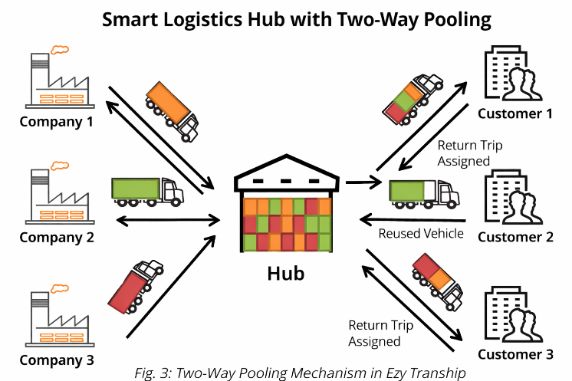
The propose methos, Ezy Tranship is designed as a smart and user friendly for transportation and logistics. The main reason to implement this system is to make it user friendly and a unified or common platforms for both goods and passengers in a very efficient, reliable, convenient, cost-effective and minimum resource wastage.
Unlike traditional systems, which are suffering from delivery delays, lack of transparency, no real time information and inefficient route planning, this system utilizes modern technologies to enhance accessibility, automate processes to reduce delays and improve overall experience.
So, our platform Ezy Tranship provides a clean and easy to use online interface by which user can easily book vehicles. This platform allows user to check real time availability and can compare routes and pricing and can be able to select the driver according to their preferences. This clearly reduces the manual efforts, saves time and ensures a smooth and reliable booking system.
One of the key features of the system is to focus on efficient resource utilisation. In traditional systems, vehicles often return empty trips which leads to fuel wastage, increased operational cost and reduced driver profit by 20%. To solve this issue, the system introduces smart two-way pooling mechanisms.
In this approach, once a trip is completed or a driver is booked for a time. Suppose a user1 book that driver from 27-March-2026 at 6:00 PM to 28-Mar-26 at 8:00 PM and driver heading to Moradabad to Delhi. So, in the route for Delhi to Moradabad if someone wants to book a driver then our algorithm shows the driver who is travelling on that route to the user and user2 will be able to book that driver after the driver completes their journey with user1 and after in results both the users will pay equivalent to half the price and driver earn more as resources are used efficiently and driver profit increases by 20 to 30% and this is the unique thing in our platform.
Overall, Ezy Tranship aims to provide a scalable, efficient, secure, reliable and eco-friendly solution for modern transportation challenges. By utilizing the resources efficiently with less wastage which helps us to Improve the overall performance of the vehicle and delivering a smooth digital experience, this system is creating a value for both users and drivers by solving the gaps in existing systems.
- METHODOLOGY
The creation of the presented system, Ezy Tranship, follows a well-defined and managed approach to ensure that the application is reliable, and great to use. The methodology mainly targets on generating a digital solution that helps in easily booking the vehicles and making the process simpler and also improving the method of transportation resources and utilization.
5.1 System Design Approach
The system we are proposing is created and built using a very new and modern approach as well as design, where different parts such as user interface, booking system, and databases are generated or developed separately and later combined in one system. This helps in making the system more flexible, easier to scale, and simpler to maintain and user friendly as it is easy to understand. To enhance and improve the user’s usage, separate interfaces are designed for customers & drivers both at same place. The whole system design keeps simplicity in mind so the users experience is fully kept in priority as they can easily navigate the platform and complete their tasks without any sort of confusion.
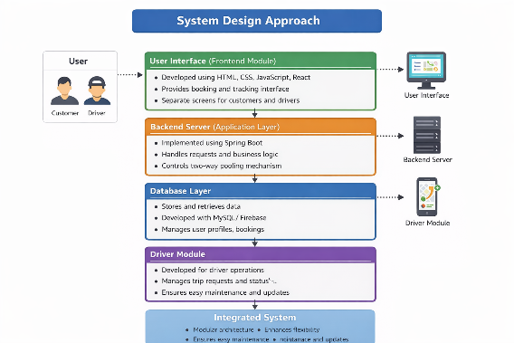
5.2 User Registration Authentication
Both customers and drivers are required to register on the platform by entering or feeding basic details. To protect the users, trust as well as the user information there are very secure authentication methods are used, and it also make sures that only authorized users can access the system.
Once logged in, users can maintain their profiles, check their booking details and record their trip history. This makes the system more convenient and secure.
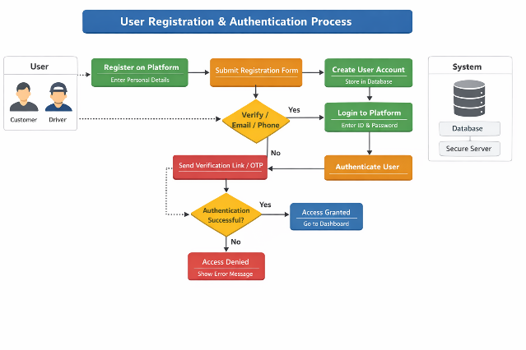
  - Vehicle Booking Process
The booking process is kept very simple and user-friendly to help the users to use it in a simple go. It is done using these steps:
- The users enter the pickup and drop locations themselves.
- The system displays the list of available vehicles in real time.
- The user can easily compare prices, routes, and driver information.
- The booking is then confirmed.
After confirmation, the request notification is sent to the driver, and their trip begins. This reduces the manual work faster and smoother.
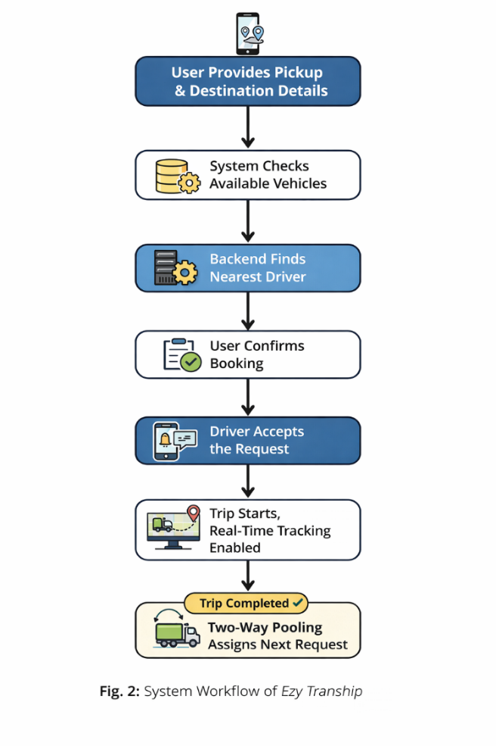
  - Real Time Availability and tracking
The system is set in a way that it continuously updates the availability of vehicles. Once the trip is completed, the driver’s status is automatically updated to “available”.
This ensure and make sure that the users always get accurate and up-to-date maintained data on the system, it is done to reduce waiting time and overall service reliability improves.
  - Two-way Pooling Mechanism
The most specific feature of the system or platform is two-way pooling mechanism, which helps solve the problem of the empty return trips which are the major loss causing problems for drivers and which makes the costing reasonable for the users also.
After trip ends the system relocates the registered vehicle again in the available list and looks for new booking request along the same or related routes. If a suitable request pops, the vehicle is assigned again instead of returning as it is. This whole scenario includes tracking trip completion, updating vehicle status, assign the vehicle according to their requirements. As a result, it shows a massive increase in vehicle usage and reduces unnecessary resource wastage.
  - Route optimization
The system uses route optimization techniques to choose the most suitable and considered efficient paths. It ensures factors like distance and route similarity to ensure faster and more reasonable as well as cost-effective travel.
This helps in saving the resources such as fuel, and time and helps in improving the overall efficiency of the system.
  - Data Management
The data stored in the system which includes user details, vehicle information, and booking records, in stored in a structured database. The system ensures that the data is properly stored in a secure way keeping the user privacy intact, easily accessible and maintained in a proper systematic way.
This improves system performance and provide a better user experience.
  - System benefits
The proposed methodology offers several key benefits:
- Smoother and Faster booking process
- Better utilization of vehicles
- Better use of resources and avoid wastage
- Higher and convenient earning for drivers
- Improved overall user experience

- SYSTEM ARCHITECTURE
The architecture of Ezy Tranship our proposed system is based on the specific model which is client-server model, which runs with no middleman or commission-based condition model, and it maintains scalability, reliability, and smooth communication between different parts of the system.
The whole structure is divided into four main layers:
- Frontend
- Backend
- Database
- Driver module
Each layer has a specific role, but all of them work together in a way to provide or to deliver a seamless transportation service.
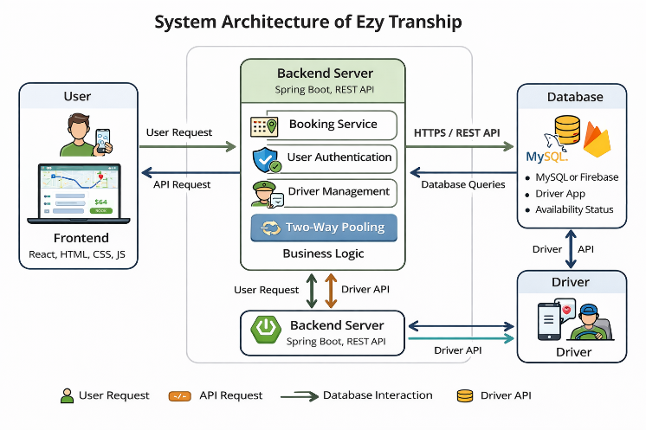
6.1 User Interfaces (front-end)
The Frontend is designed using new web technologies such as HTML, CSS, JavaScript, or framework like react. It helps in providing a smooth, clean and interactive interface for both customers and drivers.
With the help of this interface, users can easily use features to perform tasks like booking a vehicle, selecting pickup and drop location, comparing prices, and tracking their trips. The design of the interface is kept simple and easy to use so that users can easily navigate the platform without difficulty.
6.2 Backend Server (Application layer)
The backend is created using Spring Boot and handles the important functionality of the system. It verifies and goes through user requests on the prior basis, manages the login and authentication while registration, assigns drivers to the specific registered customers, and controls features like two-way pooling mechanisms.
This layer is designed to act like a passage or bridge between the frontend and the database, ensuring that the data is processed correctly and system operations runs smoothly.
  - Database Layer
The database layer uses technologies which include:
- MySQL
- Firebase
To store all important information. This includes user details, driver profiles, vehicle availability, booking history and transaction data.
It makes sure that the data is stored securely, remains consistent, and makes it easy to access whenever it is needed. Smooth and efficient data handling is essential or crucial for maintaining system performance.
6.4 Driver Module
The driver module is designed in a way that for specifically for driver to manage their activities within the platform. It makes them to accept booking request update the truck availability and track on going trips.
Once the trip is completed, the platform automatically updates the driver’s new status and makes the vehicle available for new booking, that make sures continuous service.
6.5 System Workflow
The overall working of the system follows a clear sequence of steps:
- Booking request is received from the users through frontend.
- The request is received and processed through backend.
- The nearest available driver is assigned through the database of the system.
- Booking confirmation is sent to the user.
- The real time tracking starts with the trip itself.
- The vehicle status is updated after the trip ends.
- The system uses two-way pooling mechanism.
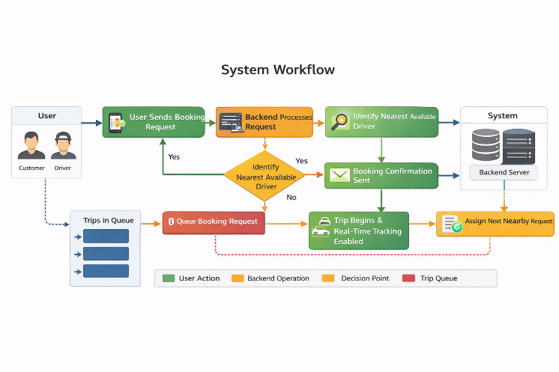

- RESULTS
The EzyTranShip has a clear vision of improvement as it gets compared to some of the home transportation methods, the focus of area is cost saving availability of resources.
6.1 Reduction in empty trips
The key benefits we can expect are two-way pooling feature; it helps in reduction of vehicle without loads. This kind of approach can help in cutting down empty trips around 35-45%, which can also lead to increase in vehicle utilization and can decrease the unnecessary travel.
6.2 Fuel Consumption Reduction
When the better route planning comes in game and the empty trips go out then the fuel usage also gifts the best output around 20-30% it helps in lowering the cost of operations and the positive side the environment is also taken care off.
  - Cost reduction
The systems offer the cost reduction to both the driver and customers, where customers get around 15-25% and on the other side drivers get 20% reductions.
  - Improve vehicle utilization
The utilisation of vehicles also improves in the upward manner with 40-50% growth, by this the idle side of vehicle will be swapped by new ready task.
  - Faster Booking Time
The booking time is also reduced to the better case whereas the tradition methods still take a hell of a time in comparison the system on this its peek time gets you a work by 30 seconds which gets us smooth and faster approach.
  - Increased driver earning
When the ideal time is neglected by that percentage drivers are awarded with increased income and tips
  - System efficiency
Afterall the system efficiency improves at 30-40% and the main improvement is because of automation. The better allocation and time tracking at real time also improvs
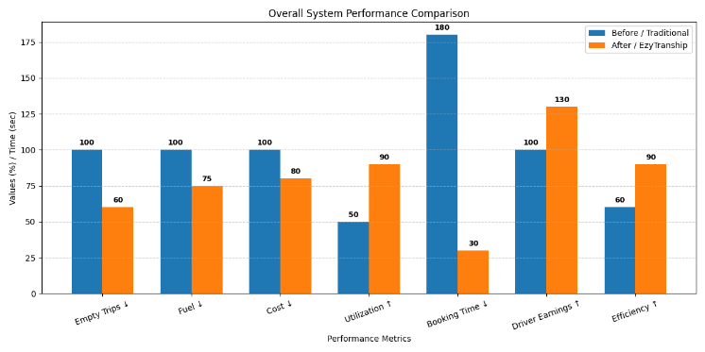

- COMPARISON
The system opts Ezy Tranship when is compared to uber freight and convoy. The main parameters are efficiency, vehicle utilisation and booking process.

8.1 Feature Based Comparison.
Feature | Ezy Tranship |  | Uber Freight | Convoy
Real-time Booking | Yes |  | Yes | Yes
Transparent Pricing | Yes |  | Yes | Yes
Two-Way Pooling |  | Yes | No | No
Empty Trip Reduction | High |  | Moderate | Moderate
Vehicle Utilization | High |  | Medium | Medium
Booking Speed | Fast (<30s) |  | Medium | Medium
User Interface | High |  | High | High

8.2 Performance Comparison.
Parameter | Ezy Tranship | Traditional Systems
Empty Trips | Reduced by 35–45% | High
Fuel Consumption | Reduced by 20–30% | High
Cost | Reduced by 15–25% | Higher
Vehicle Utilization | Increased by 40–50% | Low
Booking Time | < 30 seconds | Several minutes
Driver Earnings | Increased by 25–35% | Lower
System Efficiency | Improved by 30–40% | Moderate

8.3 Discussion
After all the comparisons we can see the clear advantageous situation of Ezy tranship over the others, as mentioned in above places the too way pooling helps us in having a better hand on others after the comparisons ,where others lac in reducing the resource wastage we offer the least possible wastage of shortage with the additional cost of drivers for better income as well ,the overall user experience is made to the better terms for the people experiencing ,overall the Ezy tranship has a better overall hand over the possible comparisons
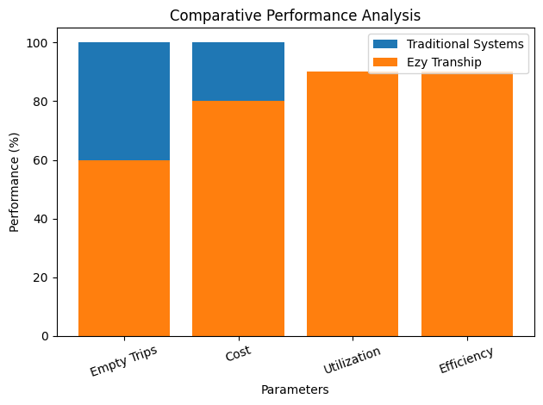

- CONCLUSION AND FUTURE SCOPE

- REFERENCES
[1]. D. Oladimeji, K. Gupta, N. A. Kose, K. Gundogan, L. Ge, and F. Liang, “Smart Transportation: An Overview of Technologies and Applications,” Sensors, vol. 23, no. 8, p. 3880, Apr. 2023.
[2]. P. Sharma and S. Singh, "A Review of Smart Transportation Systems Using IoT," IEEE International Conference on Intelligent Transportation Systems (ITSC), 2020.
[3]. M. Patel, K. Shah, and R. Mehta, “Optimization Techniques in Logistics and Supply Chain Management,” in Proc. IEEE International Conference on Smart Computing (SMARTCOMP), 2022.
[4]. S. Jain, A. Kumar, and P. Singh, "Reducing Empty Miles in Freight Transportation Using Digital Platforms," IEEE Transactions on Intelligent Transportation Systems, vol. 23, no. 5, pp. 4561–4572, 2022.
[5] Ola Cabs, “Ola – Mobility Platform,”
Available: https://www.olacabs.com
[6] Uber Technologies Inc., “Uber India – Ride Booking Services,” Available: https://www.uber.com/in/en/
[7] Rapido, “Rapido Bike Taxi Services,” Available: https://rapido.bike
[8] Delhivery Ltd., “Delhivery – Logistics and Supply Chain Services,” Available: https://www.delhivery.com
[9] Ekart Logistics, “Ekart Logistics – Supply Chain Solutions,” Available: https://www.ekartlogistics.com
[10] NITI Aayog, “Transforming India’s Mobility and Logistics through Digital Platforms,” Government of India Report, 2021.

